American Petroleum Institute

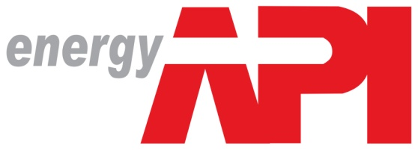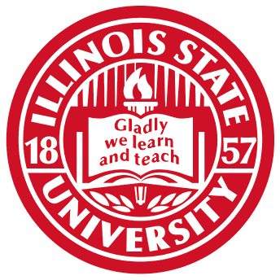

Marcus Clark
Christian Froehlich
Jessica Kim
Elyse Link

Dr. Aysen Bakir
Fall 2015, Illinois State University

Table of contents

Team Biographies 3
Executive Summary (Christian) 4
Section I: Situation Analysis 6
Industry Background (Christian) 6
Company Snapshot (Elyse) 6
Competitive Review (Elyse) 7
Buyer Analysis (Marcus) 7
Marketing Goals (Marcus) 8
Legal/Regulatory Environment (Christian) 8
API Past Campaigns (Christian) 9
Current Marketing Efforts (Christian) 9
Summary of the Key Findings and Implications for IMC (Jessica) 9
Section II: Segmentation, Target Market, and Positioning 10
Segmentation (Jessica) 10
Positioning (Jessica) 10
Target Market (Jessica) 10
Section III: Creative Strategy 12
Campaign Objectives (Christian) 12
Message Strategy (Jessica) 12
Message Appeals (Christian) 13
Executions (Everyone) 13
Section IV: Media Strategy 21
Media Recommendations and Plan (Jessica) 21
Media Recommendation (Everyone) 21
Media Breakdown (Elyse & Christian) 24
Campaign Flowchart (Marcus & Jessica) 26
Section VI: Budgeting (Everyone) 27
Section VII: Measurement and Evaluation (Christian & Jessica) 28
Conclusion (Christian) 29
Appendix A: Financial Breakdown, Media Schedule, Target Audience Profile 30
Appendix B: Creative Strategy Executions (Marcus) 32
Appendix C: Media Breakdown (Marcus) 37
Appendix D: Interview Analysis (Jessica) 42

Team Bio

Christian Froehlich is a senior at Illinois State University pursuing a degree in Marketing. He will be graduating in May of 2016 to enter the sales field. He has gained experience in sales through taking several sales courses at Illinois State University, as well as completing a sales program in The Netherlands during the summer of 2015. He went through several different sales scenarios and pitches, as well as pitched a new product to the Philips executive board. He has been involved at Illinois State through being a member of the Delta Chi Fraternity since freshman year, and a found father of the Phi Gamma Nu Professional Business Fraternity since sophomore year.

Elyse Link is a senior at Illinois State University pursuing a degree in Marketing. She will graduate in May of 2016 and enter the marketing job market. She has gained experience in marketing through her internship with Playlist HQ as a Social Media Marketing Intern. Elyse has created marketing plans and campaigns for local businesses at Illinois State. She is currently working with a Chicago based company doing marketing research. Elyse distinguished herself as a leader by joining service and leadership sorority Epsilon Sigma Alpha in 2012, and by being a section leader in Illinois State University’s all women choir, Belle Voix.

Marcus Clark is a senior IMC major at Illinois State University receiving his degree in December 2015. His marketing career got an early start when he began assisting small businesses owned my friends and family. He officially entered the field with a Marketing Communications internship with Campus Dining at ISU. Through God, hard work, and networking he has established himself as a young scholar and was invited to multiple events by the College of Business. He also was accepted into the honor society and is a devoted member of the NAACP.

Jessica Kim is a senior at Illinois State University majoring in General Marketing. She is graduating in December 2015. Jessica has completed a marketing plan for Sony's smartwatch for Marketing 338 class. Jessica has developed marketing and business skills through work and professional internships at Autonics. She was also a marketing assistant at Dhups, Inc.

Executive Summary

Our major target audience includes Illinois State University students, specifically science, technology, engineering, and math majors. We chose to focus on STEM majors because their fields of interest are most relevant to positions in which the American Petroleum Institute has to offer. After completing our research and questionnaires, we came to the conclusion that not nearly enough students know about the API. They either have a negative view towards the oil and natural gas industry or they don’t believe a career in this industry would be fulfilling. We needed to come up with objectives that would change consumer attitudes towards the API.
There are three main objectives that need to be accomplished during the duration or as a result of this marketing program. The first objective is to gain more awareness of API and the career opportunities. The second objective is to boost interest for careers within the oil and natural gas industry. The third and final objective for this marketing campaign is to inspire consideration of careers in the oil and natural gas industry. We created a catchy tagline that would help attract interest in all three of these objectives.
Our tagline is to “Energize Your Career”. This tagline is relevant to the API because it relates back to energy. It is also relevant to our mission because it tells people they can have a career in this field. It’s catchy because it uses “energy” hand-in-hand with API and employment. This tagline allows us to create a synergy between the two by putting an emphasis on the career opportunities that are available within the API. It will help our target market feel like they can have an exciting and meaningful career. It will be present in all of our executions.
Our total budget consists of $250,000. We used $247,500 of this budget through implementing several different methods to reach our target audience. The table below shows how we allocated our entire budget.

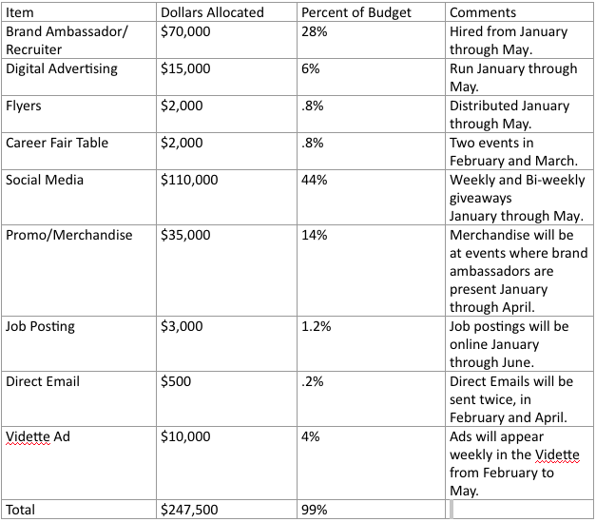
When deciding what to spend our budget on, we needed to come up with a span of how long each method will be implemented for. The chart below shows each method used and how long we plan on doing that method for.

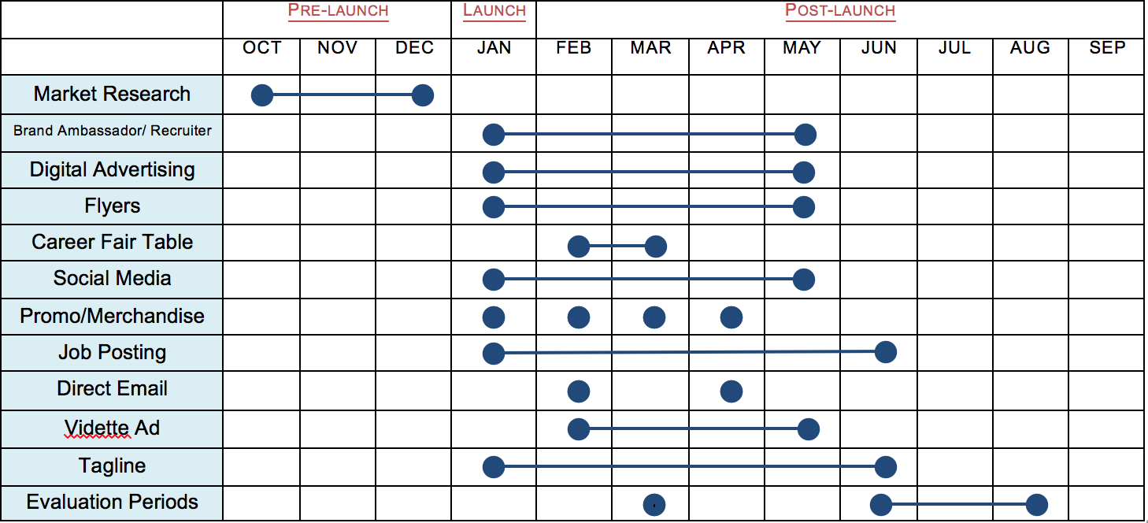

While progressing through the campaign, we plan to measure and evaluate our feedback through Google Analytics and NUVI. Google Analytics can be used to track the success of our social media sites, such as Facebook, Instagram, and Twitter. This is a free platform that can track different media usages such as number of clicks, bounce rate, likes, followers, shares, comments, page views, average session duration, etc. This will allow us to track our statistics and measure how our followers are reacting to our campaign throughout the process. We can then analyze what has been working well for us and what hasn't been working so well. NUVI is a social media analytics tools to monitor, assess and improve the social media performance. NUVI can monitor the keywords for Hashtag campaign. For accurate measurement, only Facebook, Twitter, and Instagram should be selected for the report. Through this tool we can immediately observe what people say about API and how much our campaign is influencing our target market. After analyzing both of these tools, we can adjust our campaign to align with what attracts the most attention out of our target audience.

Section I: Situation Analysis

Industry Background:
The American Petroleum Institute (API) was established on March 20th, 1919. API has offices in 21 state capitals and represents members in 33 states and is currently one of the nation’s largest trade associations. It is the only trade association that represents all aspects of America’s oil and natural gas industry. (Fanning 1)
Over the past decade, America has shifted from being energy scarce to energy abundant. The oil and natural gas industry has been experiencing economic growth through hundreds of billions of dollars of investments every year. These contributions help to create jobs and help with advancements in technology. According to Daniel Poneman, U.S. Deputy Energy Secretary, “The natural gas boom in the United States offers a tremendous opportunity to strengthen American energy security by drastically reducing our dependence on imported oil, while at the same time creating new U.S. jobs and industries” (Poneman 4).

Company Snapshot
Place in the Industry
The American Petroleum Institute is the largest trade association for the oil and gas industry. After a decline, the U.S has recently increased crude oil production due to horizontal drilling and multistage hydraulic fracturing. Production in North America has grown from 7.5 million barrels per day in 2008 to 11 million barrels per day in 2013. This is a growth of over 45% in a five-year period.

Target Market
The target market for American Petroleum Institute is organizations in the oil and natural gas industry. This includes producers, refiners, suppliers, pipeline operators and marine transporters. The reason for targeting this market is to inform them of the abundant safety and regulatory information that is important for production of oil and natural gas.

Brand Review
The focus of this campaign is to increase awareness of jobs in the oil and natural gas industry at American Petroleum Institute. Our survey results showed that nearly all of our interviewees were not familiar with the American Petroleum Institute. Many believed there was not any career opportunities for them at API, or had a negative belief associated with API. Our goal is to target Millennials aged 18-30 who have a STEM degree, and make them more aware of the many different career opportunities they could have in the oil and natural gas industry. We are challenged to increase the level of awareness, interest, and consideration of careers in this industry and promote the growing range of opportunities.

SWOT Analysis:
Strengths  - API is the only national trade association that represents all aspects of America’s oil and natural gas industry.  - More than 600 corporate members. | Weaknesses  - Minimal Awareness  - Lack of marketing
Opportunities  - Work is expanding to include a growing international dimension.  - Energy Abundance | Threats  - Independent trade associations  - Regulations imposed by government

Market Constraints
A major market constraint that affects API is the lack of communication between API and the target market of Millennials. Most of the people in this target market are not interested in energy related topics, and therefore do not actively search for this information. It is difficult for API to connect with this group through an effective medium. Before API can create awareness and interest in career opportunities in this industry, they need a proper medium to reach the target market. Social media tends to be an effective medium of gathering information for a Millennial. Their presence on social media needs to be stronger.

Competitive Review
Direct Competitors
A direct competitor of the American Petroleum Industry is the Independent Petroleum Association of America (IPAA). IPAA also represents oil and natural gas producers. They currently represent thousands of independent oil and natural gas producers and service companies across the United States. IPAA represents over 10,000 individuals and more than 200 public companies. IPAA offers regular membership for $450.
Both organizations, API and IPAA, have very similar missions and purposes. IPAA’s mission states “The Independent Petroleum Association of America is dedicated to ensuring a strong, viable domestic oil and natural gas industry, recognizing that an adequate and secure supply of energy is essential to the national economy.”
Like API, IPAA’s target market is organizations in the oil and natural gas industry, however IPAA targets the independent organizations. Both companies hold events, meetings and have educational opportunities for the companies they service. They examine the current issues in the economy to plan for the future. IPAA has press releases several times per month to keep people up to date on government decisions, economic impacts, and anything else that affect the industry.

Buyer Analysis
The user profile consist of Millennials age 18 - 30. Both men and women are included in the analysis and there was a 50/50 ratio. . The users are mainly college students in McLean County attending Illinois State University. The psychographics revolve around users wanting a good salary, a good job location, great benefits, and reasonable hours. These psychographics also pertain to the “buyer decision process.” For this campaign it will be called the “job searching decision process.” The target audience primarily uses LinkedIn, career centers, and online searching as a way to find job opportunities. Shown below is a full list of the decision criteria.
- Level of commitment
- location
- salary
- benefits
- hours
- job description
- work environment
- opportunities
- interest
- culture

Marketing Goals
There are three main objectives that need to be accomplished during the duration or as a result of this marketing program. The first objective is to gain more awareness of API and the career opportunities. The second objective is to boost interest for careers in the industry. The third and final objective for this marketing campaign is to inspire consideration of careers in the oil and natural gas industry.
After researching, our findings showed that many people had no clue of the career opportunities available in the natural gas and oil industry, which is why one of our primary objectives is to gain more awareness. Our results also yielded information that indicated many people had either no interest in the field or had negative perceptions about the industry. For this reason we decided to attempt boosting the interest in careers available. This is also the driving factor behind the last objective. Once we increase interest in the industry it will become immensely easier to then guide our target audience into considering possible careers in the natural gas and oil industry.

Legal/Regulatory Environment:
The American Petroleum Institute’s standards are to comply with regulatory and legislative requirements, safeguard health, and protect the environment. By doing these things they help industry professionals improve the cost-effectiveness and efficiency of their operations. The API is dedicated to using natural resources in order to protect the health and safety of the public. They pledge to this responsibility by ensuring the safety of their workers and the environment through these 11 principles:
- To recognize and to respond to community concerns about our raw materials, products and operations.
- To operate our plants and facilities and handle our raw materials and products in a manner that protects the environment and the safety and health of our employees and the public.
- To make safety, health and environmental considerations a priority in our planning and our development of new products and processes.
- To advise promptly appropriate officials, employees, customers and the public of information on significant industry-related safety, health and environmental hazards, and to recommend protective measures.
- To counsel customers, transporters and others in the safe use, transportation and disposal of our raw materials, products and waste materials.
- To economically develop and produce natural resources and to conserve those resources by using energy efficiently.
- To extend knowledge by conducting or supporting research on the safety, health and environmental effectiveness of our raw material, products, processes and waste materials.
- To commit to reduce overall emission and waste generation.
- To work with others to resolve problems created by handling and disposal of hazardous substances from our operations.
- To participate with government and others in creating responsible laws, regulations and standards to safeguard the community, workplace and environment.
- To promote these principles and practices by sharing experiences and offering assistance to others who produce, handle, use, transport or dispose of similar raw materials petroleum products and wastes.

API Past Campaigns
Since 2000, the American Petroleum Institute has invested over $2 trillion in U.S. capital projects to advance all forms of energy, including alternatives. They currently have campaigns against the ozone standards. They claim that they are important and need to remain where they currently are. One of their commercials states, "Don't mess with success. Don't change the strict ozone standards". The API believes if the ozone standards are changed Americans will risk their job growth and the country will get into more debt.

Current Marketing Efforts
The American Petroleum Institute currently has marketing efforts on Facebook, YouTube, Twitter, Pinterest, and a separate application. They promote the API through providing statistics on why they are important and necessary for the United States economy to thrive.
Summary of the key findings and implications for IMC
American Petroleum institute, a largest oil and gas industry in United States has been improving America's economic and offered over 9.8 million jobs for American. API wants to educate the target market, age of 18-30 years old with STEM degree, to help gain knowledge about the oil and gas industry. The research shows that many people were not educated enough about the industry, had no interest, or had negative thoughts. The lack of awareness and marketing were weaknesses of API. There was not enough communication between API and the target market to the point that many people did not even thought of obtaining job in this industry. In order to communicate with the target market more successfully, API wants to create marketing campaign using influential tools such as social media to reach the Millennials. The 3 objectives for the marketing campaign are to educate Millennials and create more awareness of API and career opportunities, gain interest in the gas and oil industry, and inspire consideration for careers in the oil and natural gas industry.

Section II: Segmentation, Target Market, and Positioning

Segmentation
The American Petroleum Institute focused on people between the ages of 18-30 years old with craft professional opportunities and a STEM degree. Their goal is to educate and inform the Millennials about career opportunities in the oil and gas industry. The research was designed to measure the level of awareness, knowledge of the oil and gas industry, interest, and considerations of careers in the field. The marketing campaign will focus on educating students to form positive thoughts on the oil and natural gas industry and inform students about possible career opportunities in this industry. This includes any people who meet the qualifications despite their gender or occupation.

Positioning
American Petroleum Institute has long been the leading company in the natural gas and oil industry. They supply the entire United States, thus holding a massive share of the market. However, when it comes to the brand image there are many negative perceptions along with it. In order to change this crippling situation API desires a marketing campaign that is properly equipped to not only increase awareness but change perception into a positive response by showing potential hires the true value and opportunity of working in the industry.API is positioning itself to inspire target market to obtain possible careers in the natural gas and oil industry by educating a target market to gain awareness and interest in the industry and company.

Target Market
The American Petroleum Institute wants marketing campaigns that can educate a target market about the oil and natural gas industry to increase their interest and awareness in career opportunities. The primary target market for API was Millennials, between the ages of 18-30 years old[1]. API wanted to focus on people with craft professional opportunities and a STEM degree as the secondary target market[2]. STEM degree includes science, technology, engineering and mathematics degrees. 13 interviewers out of 14 were Illinois State University Students and between the ages of 18-24 years old. According to the information we found, the marketing campaign will primarily focus on Illinois State University students ranging from freshman to graduate students.

Exhibit 1: Target Audience Profile

Primary Target [1] | Secondary Target [2]
Illinois State University Students  - Total estimated target audience:  Demographics  - Age: 18-30  - Gender: Male and Female  - Marital Status: Single or married  - Education: College Level  - Occupation: Looking for employment  - Income: N/A  - Location: Bloomington-Normal  - Diverse Religion and Ethnic backgrounds  Psychographics  - Level of commitment  - close location  - strong salary desired  - prefer great benefits  - want reasonable hours  - job description  - work environment  - opportunities  - interest in job worked  - ideal culture | Craft Professionals and STEM Degrees  - Total estimated target audience:  Demographics:  - Age: 18-30  - Gender: Male and Female  - Marital Status: Single or Married  - Education: STEM degree  - Occupation: Looking for employment  - Income: N/A  - Location: Bloomington-Normal  - Various Ethnic and Religious Backgrounds  Psychographics  - Level of commitment  - close location  - strong salary desired  - prefer great benefits  - want reasonable hours  - job description  - work environment  - opportunities  - interest in job worked  - ideal culture

Reference Groups
- Classmates
- Friends
- Families
- Online Job Reviews

Section III: Creative Strategy

Campaign Objectives
Most of our target audience (STEM majors between the ages of 18-31 years old) are either unaware of the benefits that come from the API, or have a negative view on what the API does to the environment. Due to this problem, our overall strategy for the American Petroleum Institute is to increase our target audience’s overall awareness of the benefits that come from the oil and natural gas industry. We can increase the awareness of this industry by showing our target market certain statistics. These statistics can be anything from the benefits that API employees receive to the benefits that the API contributes to the U.S. economy. We are looking to portray the API as a business who contributes to the environment, avoids pollution at all costs, and helps boost the U.S. economy by providing employment opportunities. Audience awareness of the API can be increased by proving that the API is a business who overall practices good ethics and operates in order to benefit U.S. citizens.
- Our first objective is to increase awareness by 20% over a 12-month period within our target market. This objective can be accomplished by using our 10 executions in the most efficient way possible.
- Our second objective is to increase the positive perception of API by 15% within a 12-month period. This can be done through demonstrating the API strives to be environmentally healthy.
- Our third objective is to increase the number of people who would be interested in working for the oil and natural gas industry by 10% within a 12-month period. This number can be increased by explaining the benefits, the work environment, and the competitive salary that the oil and natural gas industry has to offer.
Message Strategy
The message strategy is focused to increase awareness of the oil and gas industry and about the company, API. The strategy will target Millennials, especially Illinois State University students. By increasing awareness, we anticipate that increasing overall knowledge about the oil and gas industry will boost interest and easily guide students to consider career opportunities in the oil and gas industry. The problem we discovered was that API had a lack of communication with its target market. Therefore, many students did not know about the wide career opportunities that were offered by API for most majors and the benefits provided. By creating positive perceptions about the oil and gas industry, API wants college students to consider working in the oil and gas industry after graduation for a better future. To achieve our campaign objectives, API will execute creative message appeals using various sources of media to communicate with our audience. Many of the executions will be focused on creating awareness of the brand, and diminishing some of the negative perspectives people have toward API. Some executions will focus on providing valuable information regarding API and the many career opportunities.

Message Appeals
The main appeals chosen to attract consumer interest and influence their opinions would best be accomplished through a rational and informational appeal. We want to communicate to our target market that API has many career options that provide opportunities for growth. The goal is to inform the target market of the API’s growth opportunities, benefits, and reasons for existence, so that they will understand the importance of this institute. By providing rational explanations of the API, the newly informed consumer can understand how valuable careers in the oil and natural gas industry are. These valuable careers will provide a sense of fulfillment by working in an industry that is so prevalent for the U.S. to economically thrive. By increasing awareness of opportunities and benefits, and building API’s brand image, the campaign will inform our target market and increase positive perception. This should increase the number of people who would be interested in working in the oil and natural gas industry.

Executions
Brand Ambassador/Recruiter
A brand ambassador and/or recruiter will attract student interests through their information table and other recruiting materials. This ambassador will be an influential individual who is very well educated on the API. He or she will be able to inform students concrete facts about the API, answer any questions regarding the API, and most importantly, explain why the API is so important in our society. Using an ambassador/ recruiter, we can begin to shift perceptions of API through face-to-face interaction. We will allocate $70,000 of our budget to brand ambassadors/recruiters with an estimated reach of 9,000.

Digital Advertisement
Digital advertisements will be used to reach students through televisions throughout the campus in locations such as Dining Centers, Dorms, Bone Student Center, The Rec, and Library. The purpose of these digital advertisements will be to increase awareness of API and give valuable information regarding the natural gas and oil industry. Digital advertisements will also be used to encourage students to visit API at the career fair and follow them on social media. We will allocate $15,000 of our budget to digital advertisement with an estimated reach of 19,000.
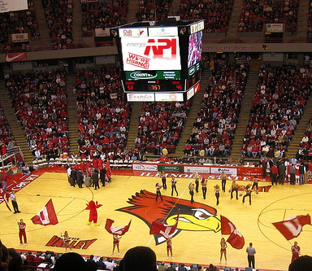

Flyers
Flyers will be posted up across campus at various high traffic locations. These locations include the quad, bone, and buildings that conduct classes. We will pay special attention to the facilities used to educate the STEM degree students. By placing the fliers at these locations we plan to increase awareness among all ISU students but also increase awareness specifically for the STEM students. We will allocate $2,000 of our budget to flyers with an estimated reach of 15,000.

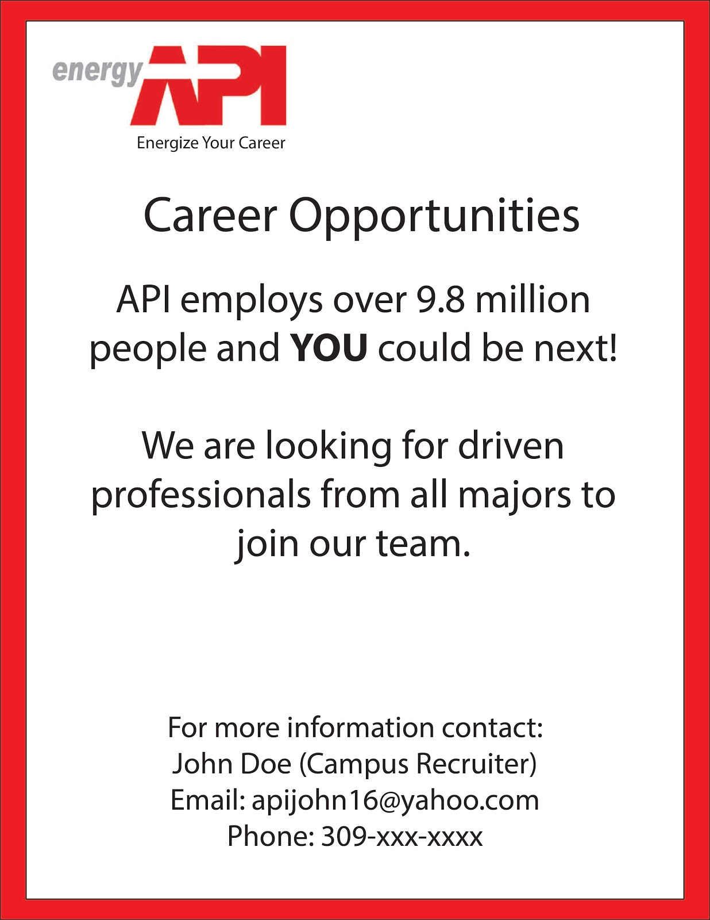

Career Fair Table
API will have a table at the ISU career fair. This provides a huge opportunity to inform students about the growing career opportunities in the natural gas and oil industry. Students will be able to talk to recruiters and gain information about growth opportunities, longevity, and compensation. This event will bring more awareness to the company and the industry, as well as increase the positive perception of API. By the end of the fair, the number of people who would consider a career in this industry will have increased. We will allocate $2,000 of our budget to career fair tables with an estimated reach of 100.

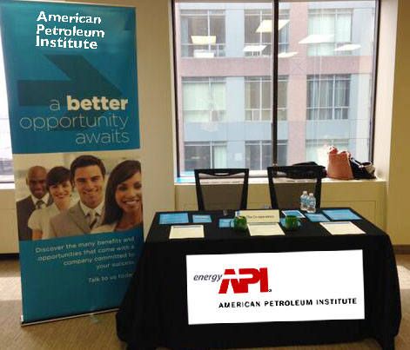

Social Media
The API Twitter account, Facebook page, and Instagram account will be important platforms to interact with the target market. The social media accounts will be used to promote events on campus like the career fair. These accounts will also provide followers with information and real time news in the natural gas and oil industry. This will increase awareness in the industry as well as increase positive perception. These platforms will also be used for our Hashtag contest. Hashtags, also called #Hashtags, allow students to share ideas, post pictures, and build communication by placing a # in front of words. The winner of hashtag marketing will receive a $100 gas gift card. A winner will be announced every week and the prize will go to the student with the most creative hashtag. The hashtag campaign will ask students to create their own hashtags that relates to the industry or company by using Facebook. When students hashtag any facts or knowledge about the industry, this creates a repository that allows any Facebook user to view the hashtag with a simple click. We will allocate $110,000 of our budget to social media with an estimated reach of 35,000.
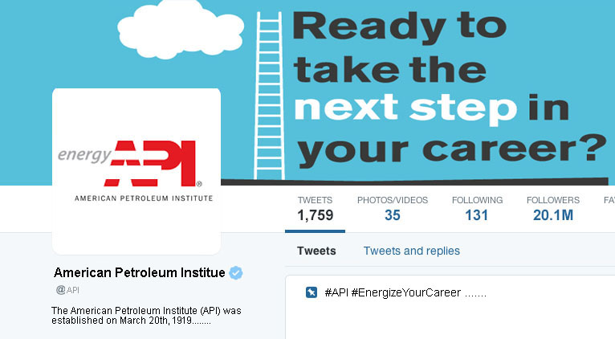

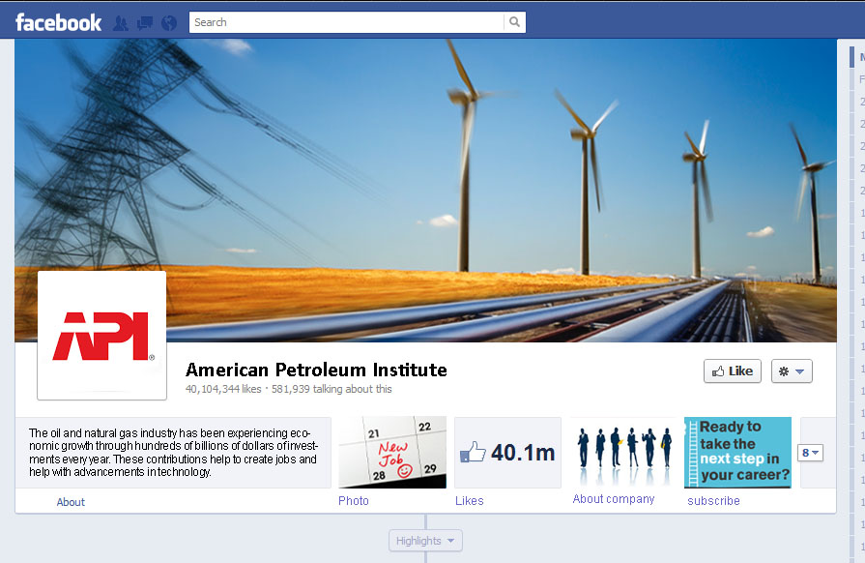
Promo/Merchandise
The promo/merchandise will go hand-in-hand with the campus ambassador/recruiter. This ambassador will receive a monthly supply of products from the API, and hand them out throughout ISU’s campus. Some of these products can include sunglasses, koozies, t-shirts, stickers, and cups. These forms of merchandise will advertise the API all throughout campus, increasing student awareness for a relatively inexpensive cost. We will allocate $35,000 of our budget to promo/merchandise with an estimated reach of 7,000.

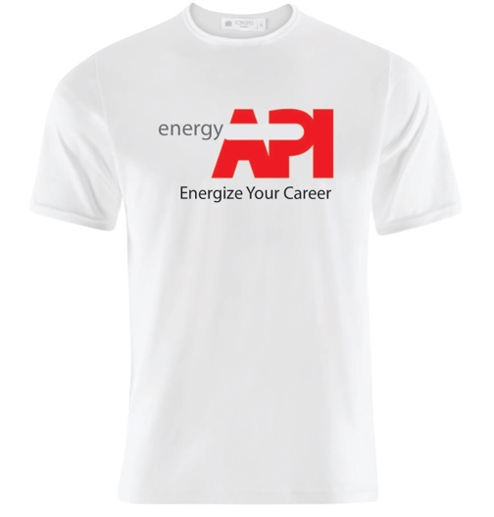

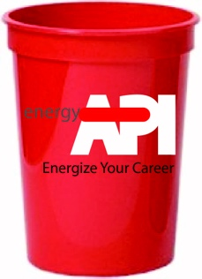
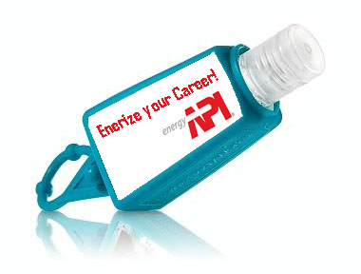

Job Postings
Having job postings in the career center, and throughout ISU, will increase awareness of the opportunities that the API offers. Students who are interested can apply online and/or contact recruiters for the API. These job postings will allow students to pursue a career in an important industry that will be around for a very long time. Some of these postings can be displayed on ISU’s science websites, business websites, technology websites, math websites, and engineering websites. We will allocate $3,000 of our budget to job postings with an estimated reach of 4,000.

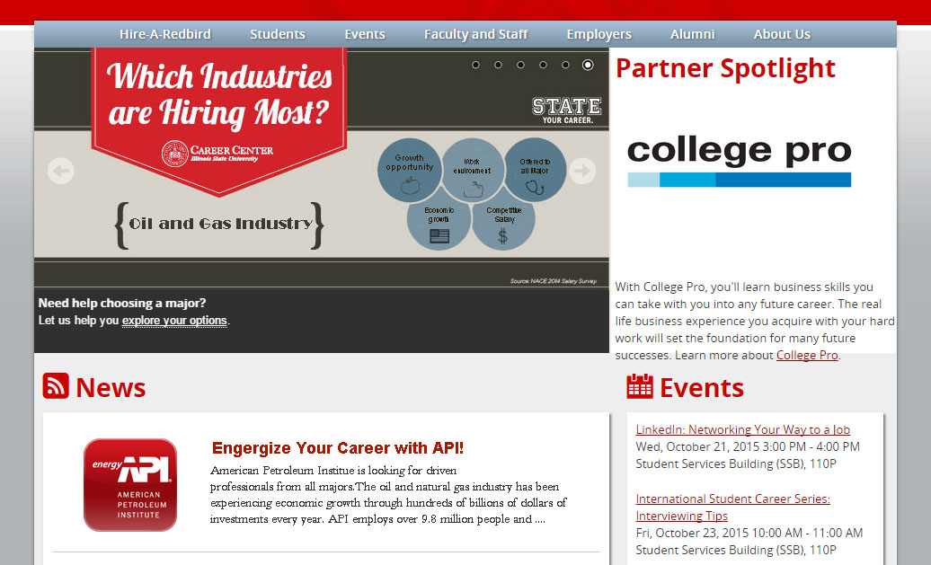

Direct Email
Working with the University Registrar Office, we will send mass emails out to ISU students with information pertaining to career opportunities. These email will help satisfy our third objective to increase the number of people interested in working in the natural gas and oil industry. A direct email can be sent to STEM majors informing them of the upcoming career fair, as well as opportunities they have in the oil and natural gas industry. We will allocate $50

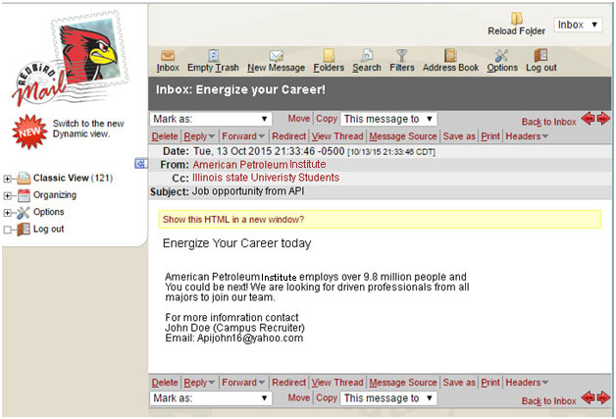

Vidette ad
Placing advertisements in the student newspaper/online will be beneficial to API. Using the readership of the Vidette can increase our reach to our target market and be more effective in increasing awareness campus-wide. Vidette newspapers are placed all over campus, which will allow us to get the API noticed as much as possible. There is also the opportunity to use the Vidette’s online readership. We will allocate $10,000 of our budget to Vidette ads with an estimated reach of 8,000.

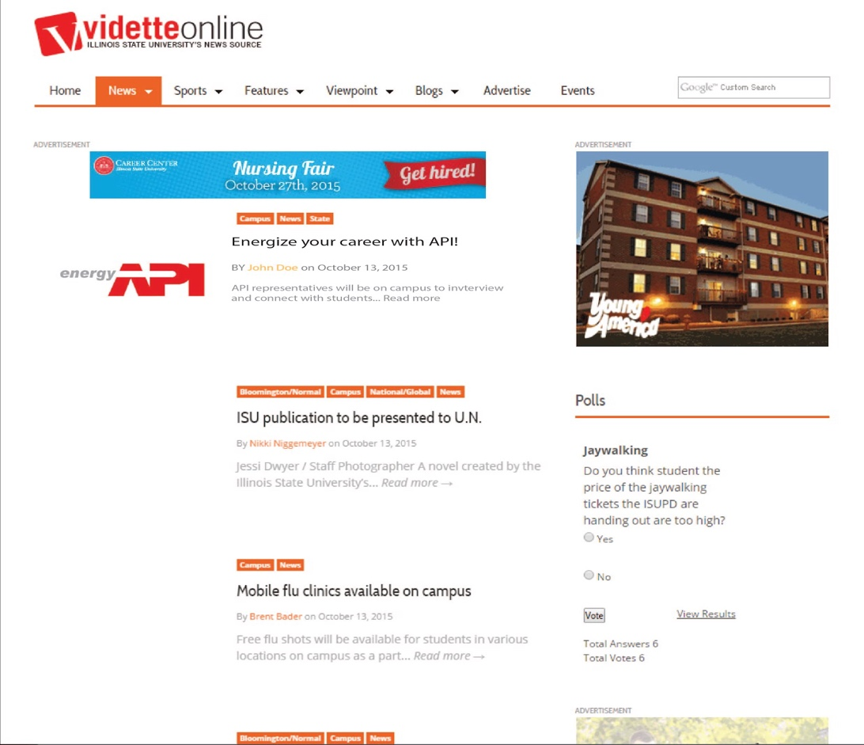

Tagline
“Energize Your Career”. This tagline is relevant to the API because it relates back to energy. It is also relevant to our mission because it tells people they can have a career in this field. It’s catchy because it uses “energy” hand-in-hand with API and employment. This tagline allows us to create a synergy between the two.

Section IV: Media Strategy

Media Recommendations and Plan
The first media recommendation for API is to be connected with the career center to make sure that Illinois State University students receive information about API's career opportunities directly from the school. Many students mentioned that they use the career center and school resources to find post-college job opportunities. The career center can effectively reach the specific target market since students who are connected with the career center are interested in finding future careers and many students are aware of the school's career assistance program. Job postings at the career center or information about API on the school's web page will directly offer information regarding job positions and increase student's awareness of the company.
Second Recommendation for API is to use direct email to reach a large population of students. This can help us connect with all students or specific students. Direct email is a highly targeted method and cost effective. This media can contain any information about the company, job opportunities, or appealing brochures. Using the school's email to send out information will be helpful because it is a more reliable and reputed account. Whether students are interested in career opportunities or not, mentioning the company and providing information itself will increase overall awareness. Mass emails can continuously reach out to ISU students to keep students updated.
Social media is very popular among our target markets, so Millennials are an important component for API. According to our interview, social media was a dominant type of media that students respond to most effectively. Social Media will include Facebook, Instagram, and Twitter for this marketing campaign. On the company's social media page or account, API can share photos, the description of upcoming events, information about the company, and opportunities for future careers. Developing social media is absolutely recommended. API can join or become friends with other groups that have similar interests so they can be connected with more social media users and influencers. Also, Hashtag contests can be used on social media to offer prizes every month. Offering those prizes will increase the number or participants for the event and allows API to increase awareness and create a better brand image to any social media user.

Media Recommendations
One of the main objectives of our campaign is to increase awareness. In order to create as much awareness as possible, we are using a variety of mediums. The more mediums that are used, the greater the probability people will come to recognize the brand. We are keeping the API logo the same, but we are adding a new tagline to each of our executions that says "Energize Your Career". We hope this will send a strong message to our audience. The mediums that we see best suited for the campaign include: Digital ads, flyers, career fair tables, social media, brand ambassadors, promo merchandise, job postings, direct e-mails, and Vidette ads.

Tagline
The tagline "Energize Your Career", was created to put emphasis on the career opportunities that are available at API. The tagline directly relates to energy from API. It will help our target market feel like they can have an exciting and meaningful career at API. It will be present in all of our executions.

Digital Ad
Digital Ads are a good way for us to reach a large amount of people in our target market. They will be seen throughout many of the buildings at Illinois State for an extended amount of time. Digital Ads can be changed and provide different messages easily. We intend to have a message informing students of the career fair and internship fair that API will be present at. It also can provide a message that lets our target audience know that API has a variety of career opportunities available. On top of the messages it provides, it also allows us to share our social media sights that will have many different messages to share.

Flyers
Using flyers is going to be a great way for us to get our message out at a very low cost. The goal of the flyers is to have information available at all times in the high traffic locations across campus. They will also assist in reminding viewers to look further into API opportunities. The flyers will be posted at eye level where possible along with a stack available beneath. Lastly, the flyers will increase reach as they move through the hands of students during the course of a day.

Career Fair Table
The career fair table will be an excellent location for getting the API message out. Students that approach the table will already be interested in finding potential careers. This will be a great opportunity to further distribute flyers, merchandise, and social media information. Another use of this table will be to obtain direct contact information from the students who stop by. This includes addresses, phone numbers, emails, and anything else that can be found on a resume.

Social Media
Social media is very popular among our target markets, Millennials are an important component for API. According to our interview, social media was a dominant type of media that students respond to most effectively. Social Media will include Facebook, Instagram, and Twitter for this marketing campaign. On the company's social media page or account, API can share photos, the description of upcoming events, information about the company, and opportunities for future careers. Developing social media is absolutely recommended. API can join or become friends with other groups that have similar interests so they can be connected with more social media users and influencers. Also, Hashtag contests can be used on social media to offer $500 gas cards every week and a $10,000 car every other week for 5 months. Offering those prizes will increase the number or participants for the event and allows API to increase awareness and create a better brand image to any social media user.

Brand Ambassador
The brand ambassadors in this campaign are going to be crucial for the success of the campaign. Students trust other students so the communication between the target audience and API will be most effective when provided through brand ambassadors. Brand ambassadors will be present throughout the campaign. They will have extensive knowledge of the company, career opportunities, and will help promote a really positive attitude with API. They will be on campus for the career fairs, and will also be passing out the promo merchandise and flyers.

Promo Merchandise
Promo merchandise will be used due to its ability to consistently reach a large portion of students at ISU. This is demonstrated through shirts, hand sanitizer dispensers, and cups. This aspect of our marketing campaign allows us to frequently reach students at a very low cost. The merchandise will display our tagline stating, "Energize your Career'. This will show students how we relate to energy along with having them think about their career in the near future. Having different methods of promoting the API through our merchandise will be very beneficial because it allows the students to notice it on campus, and become more familiarized with the API on a daily basis.

Job Posting
Connecting with the Career Center ensures that Illinois State University students receive information about API's career opportunities directly from the school. Many students mentioned that they use the career center and school resources to find post-college job opportunities. The career center can effectively reach the specific target market since students who are connected with the career center are interested in finding future careers and many students are aware of the school's career assistance program. Job postings at the career center or information about API on the school's web page will directly offer information regarding job positions and increase student's awareness of the company.

Direct Email
Direct email will reach a large population of students. This can help us connect with all students or specific students. Direct email is a highly targeted method and cost effective. This media can contain any information about the company, job opportunities, or appealing brochures. Using the school's email to send out information will be helpful because it is a more reliable and reputed account. Whether students are interested in career opportunities or not, mentioning the company and providing information itself will increase overall awareness. Mass emails can continuously reach out to ISU students to keep students updated.

Vidette Ad
The Vidette newspapers are found all throughout campus. Whether as you enter different buildings, in classrooms, or on the ground, students see the Vidette everywhere. Having advertisements in the Vidette will allow the API to not only get noticed by ISU students, but can explain opportunities within the industry as well. Since the Vidette is so popular throughout ISU's campus, the API can easily get noticed by students.

Media Breakdown

Medium: | Digital Advertisement
Scheduling Pattern: | The digital advertisements will start appearing on the school TVs starting in January and will continuously run through May
Rationale: | The digital advertisement will have the company's logo and tagline. It will advertise that API is hiring and that students can visit their table at the Internship and Career fairs. It will also have their social media information available.
Reach | Frequency | Cost-Per-Thousand  (CPM)
19,000 | 10 | $526.31

Medium: | Flyer
Scheduling Pattern: | The flyers will go up around campus starting in January. They will occasionally need to be replaced due to wear and tear until May when students leave campus. Flyers will also be handed out when brand ambassadors are on campus as well as during career fair appearances.
Rationale: | They flyer has API's tagline and logo. It is used to inform the audience of the career opportunities that are available at API. It also has information about the campuses brand ambassador/recruiter, and social media information as well.
Reach | Frequency | Cost-Per-Thousand  (CPM)
15,000 | 4 | $133.33

Medium: | Career Fair Table
Scheduling Pattern: | API will be present at the schools Internship fair on February 16, and the Career fair on March 15.
Rationale: | This provides a huge opportunity to inform students about the growing career opportunities in the natural gas and oil industry. This will increase the number of people interested in pursuing a career in this industry after they learn of the benefits offered.
Reach | Frequency | Cost-Per-Thousand  (CPM)
100 | 2 | $133.33

Medium: | Social Media
Scheduling Pattern: | The social media aspect will take place from January through May. This will include a weekly giveaway for students who interact with the API over social media.
Rationale: | A Twitter, Facebook, and Instagram account will be noticed by the student population due to the heavy increase of social media usage. These will be used for our hashtag contest along with promoting our upcoming events. Every two weeks a student will win a $10,000 car through the hashtag contest as well.
Reach | Frequency | Cost-Per-Thousand  (CPM)
35,000 | Varies | $285.71

Medium: | Brand Ambassador/Recruiter
Scheduling Pattern: | The brand ambassador will periodically be on campus handing out promo merchandise, flyers, and be present at the career fairs.
Rationale: | He or she will represent the API throughout Illinois State's campus. They will do so by attracting student interests through an information table and other recruiting tools.
Reach | Frequency | Cost-Per-Thousand  (CPM)
9,000 | 8 | $222.22

Medium: | Promo/Merchandise
Scheduling Pattern: | The merchandise will take place from January until April. It will be present at career fairs, at the recruiter's table, and other events as well.
Rationale: | This goes hand-in-hand with the recruiter. The recruiter will give out the merchandise, which will advertise the API throughout campus for a very cheap cost.
Reach | Frequency | Cost-Per-Thousand  (CPM)
7,000 | 4 | $5,000

Medium: | Job Postings
Scheduling Pattern: | The job posting will first appear in January and be on job search websites until the end of June.
Rationale: | Having these in the career center, and throughout ISU, will increase awareness of the opportunities that the API offers.
Reach | Frequency | Cost-Per-Thousand  (CPM)
4,000 | Varies | $750

Medium: | Direct Email
Scheduling Pattern: | Direct Emails will be sent to professors and students shortly before each career fair reminding them of the upcoming fairs. Another direct email will be sent after the career fairs reminding them of the career opportunities available.
Rationale: | With help from the University Registrar Office, mass emails will be focused on STEM majors. These can attract awareness of the API at career fairs and other upcoming events.
Reach | Frequency | Cost-Per-Thousand  (CPM)
6,000 | 4 | $83.33

Medium: | Vidette Ad
Scheduling Pattern: | Vidette advertisements will take place from February to may. They will be placed in the newspaper for every week.
Rationale: | Vidette newspapers are placed all over campus and are widely read throughout the student population. We can increase awareness through having articles in these newspapers.
Reach | Frequency | Cost-Per-Thousand  (CPM)
8,000 | 3 | $1,250

Campaign Flowchart

Section V: Budgeting

The proposed budget outlines expected costs for the marketing plan. Social Media accounts for over 40% of our budget, so that we can have a great incentive for consumers to interact with our brand. Since our target market is Millennials, social media is going to be a very effective way for us to affect their attitude towards API. Brand Ambassadors also make up a large portion of our budget. API relies on these people throughout the campaign to be informative and relatable people to our target market. It is their responsibility to make sure all parts of the campaign run smoothly.
Promotional merchandise is a fun way for API to reach Millennials and highlight our tagline, "Energize Your Career". 14% of our budget will be spent on merchandise that is useful and has a lasting shelf life.
Proposed budget: $250,000
Item | Dollars Allocated | Percent of Budget | Comments
Brand Ambassador/ Recruiter | $70,000 | 28% | Hired from January through May.
Digital Advertising | $15,000 | 6% | Run January through May.
Flyers | $2,000 | .8% | Distributed January through May.
Career Fair Table | $2,000 | .8% | Two events in February and March.
Social Media | $110,000 | 44% | Weekly and Bi-weekly giveaways January through May.
Promo/Merchandise | $35,000 | 14% | Merchandise will be at events where brand ambassadors are present January through April.
Job Posting | $3,000 | 1.2% | Job postings will be online January through June.
Direct Email | $500 | .2% | Direct Emails will be sent twice, in February and April.
Vidette Ad | $10,000 | 4% | Ads will appear weekly in the Vidette from February to May.
Total | $247,500 | 99%

Section VI: Measurement and Evaluation

Google Analytics
Google Analytics can be used to track the success of our social media sites, such as Facebook, Instagram, and Twitter. This is a free platform that can track different media usages such as number of clicks, bounce rate, likes, followers, shares, comments, page views, average session duration, etc. This will allow us to track our statistics and measure how our followers are reacting to our campaign throughout the process. We can then analyze what has been working well for us and what hasn't been working so well. After analyzing, we can adjust our campaign to align with what attracts the most attention out of our target audience.

Survey
Survey was sent out at the beginning of the campaign to measure the awareness of the brand and career opportunity in the oil and gas industry, and identify factors about target market's job search behavior. Similar survey will be sent out end of the campaign to measure the accomplish level of each objectives and overall effectiveness of the campaign.

NUVI
NUVI is a social media analytics tools to monitor, assess, and improve the social media performance. NUVI can monitor the selected keyword for the Hashtag campaign. For accurate measurement, only Facebook, Twitter, and Instagram should be selected for our campaign report. NUVI provides variety of measurement about the keyword such as spike analysis, reach and spread, sentiment meter, mention board, and top influencers. For example, sentiment meter provides the percentages for the positive, negative, and neutral sentiment associated with the keyword. We can immediately observe what people say and feel about API, and how much our campaign is influencing our target market.

Conclusion

Our team believes we have a very strong campaign for the American Petroleum Institute. We built the campaign around the understanding that we needed to increase awareness of jobs in the oil and natural gas industry at American Petroleum Institute. Our survey results showed that nearly all of our interviewees were not familiar with the American Petroleum Institute. Many believed there was not any career opportunities for them at API, or had a negative belief associated with API. The campaign created will be the most effective method for API to reach their target audience and accomplish the objectives established.
Our first objective is to increase awareness by 20% over a 12-month period within our target market. This objective can be accomplished by using our 10 executions in the most efficient way possible. Our second objective is to increase the positive perception of API by 15% within a 12-month period. This can be done through demonstrating the API’s strive to be environmentally healthy. Our third objective is to increase the number of people who would be interested in working for the oil and natural gas industry by 10% within a 12-month period. This number can be increased by explaining the benefits, the work environment, and the competitive salary that the oil and natural gas industry has to offer.
The marketing executions selected are designed to tackle those issues previously stated and achieve the goals of the campaign. The executions include hiring a brand ambassador, creating digital advertisements, flyers, career fair table, social media, merchandise, job postings, Vidette ads, direct emails, and a Hashtag. The executions will communicate the message of API and work to influence preferred behavior.

Appendices

Appendix A: Financial Breakdown

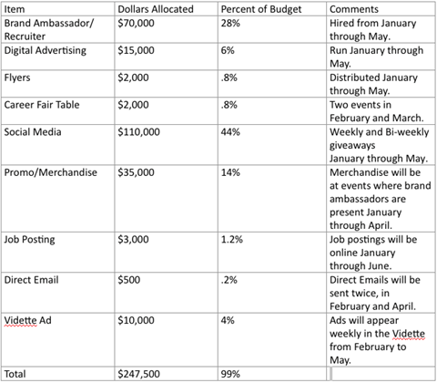

Media Schedule

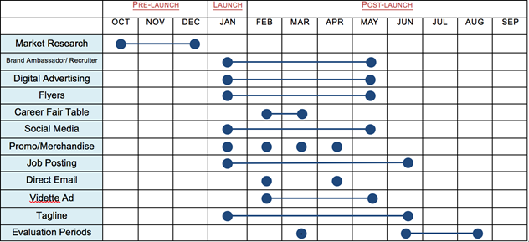

Target Audience Profile

Primary Target [1] | Secondary Target [2]
Illinois State University Students  • Total estimated target audience:  Demographics  • Age: 18-30  • Gender: Male and Female  • Marital Status: Single or married  • Education: College Level  • Occupation: Looking for employment  • Income: N/A  • Location: Bloomington-Normal  • Diverse Religion and Ethnic backgrounds  Psychographics  • Level of commitment  • close location  • strong salary desired  • prefer great benefits  • want reasonable hours  • job description  • work environment  • opportunities  • interest in job worked  • ideal culture | Craft Professionals and STEM Degrees  • Total estimated target audience:  Demographics:  • Age: 18-30  • Gender: Male and Female  • Marital Status: Single or Married  • Education: STEM degree  • Occupation: Looking for employment  • Income: N/A  • Location: Bloomington-Normal  • Various Ethnic and Religious Backgrounds  Psychographics  • Level of commitment  • close location  • strong salary desired  • prefer great benefits  • want reasonable hours  • job description  • work environment  • opportunities  • interest in job worked  • ideal culture

Appendix B: Creative Strategy Executions
Digital Advertisement
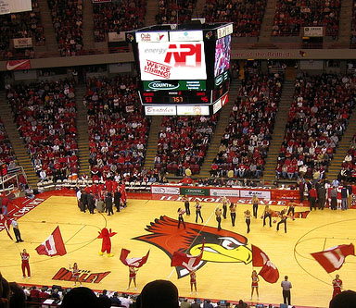

Flyers
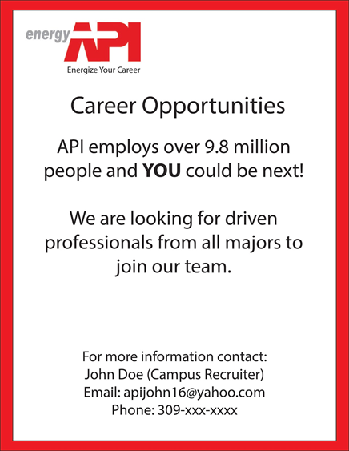
Career Fair Table
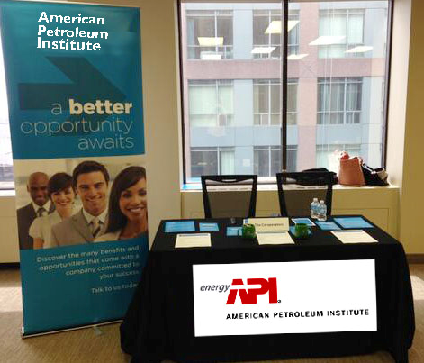

Promo/Merchandise
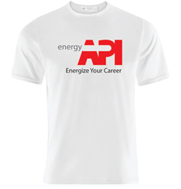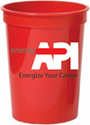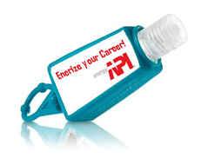

Social Media
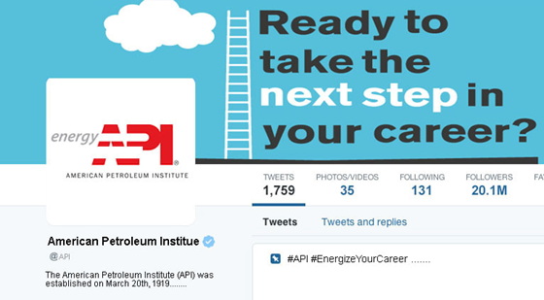

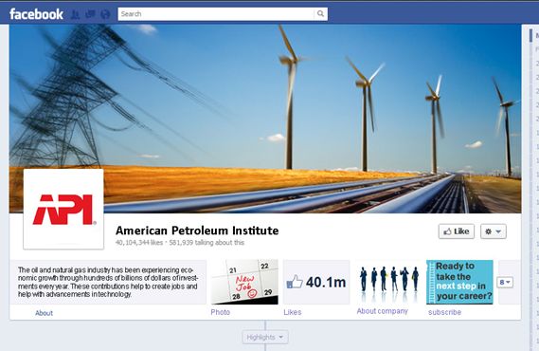

Job Postings
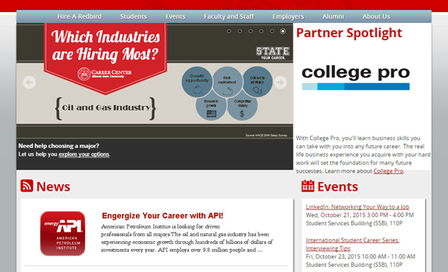

Direct Email
Vidette Ad
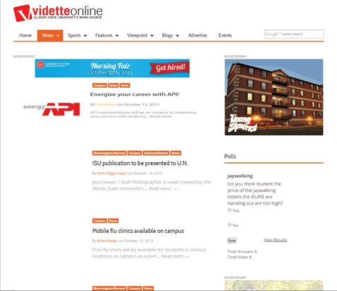

Appendix C: Media Breakdown
Medium: | Digital Advertisement
Scheduling Pattern: | The digital advertisements will start appearing on the school TVs starting in January and will continuously run through May
Rationale: | The digital advertisement will have the company's logo and tagline. It will advertise that API is hiring and that students can visit their table at the Internship and Career fairs. It will also have their social media information available.
Reach | Frequency | Cost-Per-Thousand  (CPM)
19,000 | 10 | $526.31

Medium: | Flyer
Scheduling Pattern: | The flyers will go up around campus starting in January. They will occasionally need to be replaced due to wear and tear until May when students leave campus. Flyers will also be handed out when brand ambassadors are on campus as well as during career fair appearances.
Rationale: | They flyer has API's tagline and logo. It is used to inform the audience of the career opportunities that are available at API. It also has information about the campuses brand ambassador/recruiter, and social media information as well.
Reach | Frequency | Cost-Per-Thousand  (CPM)
15,000 | 4 | $133.33

Medium: | Career Fair Table
Scheduling Pattern: | API will be present at the schools Internship fair on February 16, and the Career fair on March 15.
Rationale: | This provides a huge opportunity to inform students about the growing career opportunities in the natural gas and oil industry. This will increase the number of people interested in pursuing a career in this industry after they learn of the benefits offered.
Reach | Frequency | Cost-Per-Thousand  (CPM)
100 | 2 | $133.33

Medium: | Social Media
Scheduling Pattern: | The social media aspect will take place from January through May. This will include a weekly giveaway for students who interact with the API over social media.
Rationale: | A Twitter, Facebook, and Instagram account will be noticed by the student population due to the heavy increase of social media usage. These will be used for our hashtag contest along with promoting our upcoming events. Every two weeks a student will win a $10,000 car through the hashtag contest as well.
Reach | Frequency | Cost-Per-Thousand  (CPM)
35,000 | Varies | $285.71

Medium: | Brand Ambassador/Recruiter
Scheduling Pattern: | The brand ambassador will periodically be on campus handing out promo merchandise, flyers, and be present at the career fairs.
Rationale: | He or she will represent the API throughout Illinois State's campus. They will do so by attracting student interests through an information table and other recruiting tools.
Reach | Frequency | Cost-Per-Thousand  (CPM)
9,000 | 8 | $222.22

Medium: | Promo/Merchandise
Scheduling Pattern: | The merchandise will take place from January until April. It will be present at career fairs, at the recruiter's table, and other events as well.
Rationale: | This goes hand-in-hand with the recruiter. The recruiter will give out the merchandise, which will advertise the API throughout campus for a very cheap cost.
Reach | Frequency | Cost-Per-Thousand  (CPM)
7,000 | 4 | $5,000

Medium: | Job Postings
Scheduling Pattern: | The job posting will first appear in January and be on job search websites until the end of June.
Rationale: | Having these in the career center, and throughout ISU, will increase awareness of the opportunities that the API offers.
Reach | Frequency | Cost-Per-Thousand  (CPM)
4,000 | Varies | $750

Medium: | Direct Email
Scheduling Pattern: | Direct Emails will be sent to professors and students shortly before each career fair reminding them of the upcoming fairs. Another direct email will be sent after the career fairs reminding them of the career opportunities available.
Rationale: | With help from the University Registrar Office, mass emails will be focused on STEM majors. These can attract awareness of the API at career fairs and other upcoming events.
Reach | Frequency | Cost-Per-Thousand  (CPM)
6,000 | 4 | $83.33

Medium: | Vidette Ad
Scheduling Pattern: | Vidette advertisements will take place from February to may. They will be placed in the newspaper for every week.
Rationale: | Vidette newspapers are placed all over campus and are widely read throughout the student population. We can increase awareness through having articles in these newspapers.
Reach | Frequency | Cost-Per-Thousand  (CPM)
8,000 | 3 | $1,250

Appendix D: Interview Analysis
1. What was/is your area of study?
Science
Chemistry
Chemistry
Physics
Environmental Science

Technology
Computer information systems with a focus in network security.
Information Technology

Mathematics
Mathematics, english

Not a STEM degree
Social Work
Nursing
Psychology
Recreation Management
Public accounting
Business marketing
Marketing/IMC and Graphic Design
2. In your opinion, what is an industry that you believe is vastly growing and creating many job opportunities along the way?
The health industry
Geriatrics
The tech industry
Cyber security
Computer programming
Physician assistants. Because the need and popularity of PA's continues to grow to address physician shortages especially in rural areas.
The hospitality industry
I believe the technology sector is growing very rapidly and creating many new jobs. Many new technology start-ups present the opportunity to grow into multimillion dollar companies that will employ many people.
Trucking industry, and building contractors, computer systems design and related services
All things involving Technology
I feel that general marketing is a vastly growing company, and that is what pushed me towards pursuing this degree
Marketing through social media. New services and technologies are coming out so fast it’s hard to keep up, and if you can be on the leading edge of things you can take advantage of the new developments
Engineering
Technology
3. What type of career are you interested in?
Undecided
Nursing RN/Pediatrics
Any career in the tech industry, possibly in web development or software engineering.
finance
Medical field
Psychologist
Hospitality and Tourism
I plan on entering the job force as a public accountant
Chemistry careers
A career in my field of chemistry
My dream job would be to work for the Indianapolis Colts one day. But I am open to other jobs as well
I want to do something with creative work, probably through marketing with a smaller firm where I can have more control
Non-Profit organizations. Recruiting
Something in either technology or business, maybe consulting

4. What are three or more important factors you
consider when searching for a new job opportunity?
level of commitment | 4.76% (2)
Location | 21.43% (9)
Salary | 23.81% (10)
Benefits | 7.14% (3)
hours | 9.52% (4)
job description | 7.14% (3)
Work environment | 9.52% (4)
opportunities | 9.52% (4)
interest | 2.38% (1)
Culture | 4.76% (2)

5. How do you go about obtaining information about potential job opportunities? Give three answers.
LinkedIn, Google search, networking
LinkedIn, Career Center/Career Fairs, Advisor
Checking companies websites, LinkedIn, peer reviews
Career boards, online research, networking
Online research, recommendations, and organization to ask.
Networking. Online research. Job list servs.
Word of mouth, Google, school resources
I would first gather information from the company’s website about the position and company culture. I then would Google the company/job opportunity and conduct research outside of the company’s website. I then would ask my friends and colleagues if they have any information on the position and company
Snagajob.com , Job/company websites, and Newspapers
Haven’t really started looking yet
LinkedIn is useful.. Other hiring websites for part-time jobs like Indeed.com is also very useful..
Glassdoor.com usually has good insights about the work environment. If I can find someone who works there or has any information about it I tend to trust that just as much. I might just Google their name to try to find pictures of the offices, their social media presence, etc.. – that usually gives a good idea of what the company is like.”
LinkedIn, emailing companies, asking friends.
University career center, company websites, networking like LinkedIn

6. What types of media do you respond to most effectively? (I.e. social media, television, magazine, etc.)
Social Media
Social media
Social media
Social media
Social media
Social media
Social media
Social media
Social media
Social media
I use social media such as FaceBook and Instragram often
Lately I haven’t been watching too much cable television, as I mainly watch Netflix or YouTube. I also have adblock installed on my computer to avoid ads..ha. But I do enjoy funny advertisements or when companies try to effectively respond to consumers on their social media pages
I don’t have cable (only Netflix) so I hardly ever see TV ads.. I don’t usually buy magazines and I don’t subscribe to any.. Social media is definitely the biggest. If I see something that catches my eye there’s a good chance I’ll click on it and check it out, or at least notice and remember it.
Television
Television
Television
Television
Television

Internet
Internet news sources

7. What effect does energy have on your life?
It provides me with electricity
Its essential
Little to no effect
Use it every day
Define how we live today. We use for everything
Energy plays an important role – positive or negative energy can impact the way you feel/behave.
It’s important because of how much our society relies on technology
Energy is not something I am very concerned or worried about losing but I am very reliant on energy. I use energy for many sources of technology, business, and school work.
Changes in energy demand will likely affect greenhouse gas emissions, but the net effect depends on which energy sources are used for electricity and heating. Energy in my everyday life gives me the strength to move and helps me get the job done.
Energy is pretty much the foundation of society today. Without it we would still be riding on horseback.
Energy is a significant factor in my life. Without access to electricity or gasoline would make my life very difficult, and almost impossible to keep up in today’s world.”
Ummm… My car doesn’t have great gas mileage and I have to keep my A/C on all the time so I always like cheap gas/electric
A big one. I use it every single day and it is a topic that I am interested in and I may build my career around the subject of energy. I am interested in expanding on our sources of energy that are more sustainable and ethical.
I try to make environmentally green decisions when I can, as energy powers a lot in my daily life from heat in the winter to my car

8. How familiar are you with American Petroleum Institute?
Not Familiar | 92.86%(13)
Somewhat familiar | 7.14%(1)
Very Familiar | 0

9. Do you know anyone who works in the natural gas and oil industry?
Yes | 14.29% (2)
No | 85.71% (12)

10. Have you ever considered a career in the natural gas and oil industry?
Yes | 7.14% (1)
No | 92.86(13)

Reason for Yes
Interested
commodity markets
Reason for No
Not interested
not interested
lack of interest, lack of understanding, not related to major
I have just never been interested in the field/topic.
no. Natural Industry isn’t something that I am interested in.
No. I just never thought of it
No. I haven’t really looked into it to be honest

Not enough knowledge in the industry
I’m not familiar with the types of opportunities there are for me in that particular industry.
I don’t know anything about it
No. Never heard of anything.
Doesn’t relate to major
No, because I am an accounting major that have always been planning on entering the workforce as a public accountant.
Negative opinion
Because I have ethical concerns with those industries. I believe they are hurting the environment
I have never really considered it, but from what I know (which is not much) it does not seem like there would be exciting opportunities for a new graduate studying CompSci and math

11. In your opinion, what kind of career opportunities does the natural gas and oil have to offer?
Hands on dirty work
Outdoor, hands on, dirty work
Engineering and geographical opportunities
For my industry, commodity trading
I'm not sure
There are tons of job opportunities associated with this field – engineer, lobbying, general counsel, business administration, customer service, analysts, labor, etc.
Probably a lot
I believe there is a lot of money in gas and oil and that there are very large companies in that sector. I believe this would provide generous pay and many different career opportunities.
Partnership for cleantech and natural gas, and transportation opportunities.
Probably all the basics to run a company along with drilling and engineering opportunities.
As with most industries, there are going to be bottom line workers all the way up through to upper management. But I’m not quite sure on the overall specifics.”
Besides office/administrative jobs? A lot of workers all around the country fixing and checking out issues with equipment.. Surveying sites for digging
People who go around and try to get people to give up their land to drill for gas. Manual Labors. Statisticians
Chemical or petroleum engineering positions
12. Which country do you think produces the most natural gas? Oil?
(Some respondents were unsure which caused the numbers to be a little off. Thus, percentages not provided)
America, America
America, America
Saudi Arabia and other countries in the middle east
Idk natural gas, oil is Saudi Arabia
Saudi Arabia
Natural gas from US; Oil from Saudi Arabia
Natural Gas - United States – Oil – Saudi Arabia
I think that Saudi Arabia produces the most gas and oil. Followed by Russia.
The United States, Russia, China
The U.S
I’ve heard that the United States produces the most natural gas, but I may be wrong? Also, I am fairly confident that Saudi Arabia is the world’s largest oil producer.
Saudi Arabia? Is it a trick question? If it’s a trick question then I’ll say the US.
USA. Somewhere in the Middle East.
Oil is Saudi Arabia, US for natural gas

12. Which country do you think produces the most natural gas? Oil?
 | Natural Gas | Oil
America | 8 | 3
Saudi Arabia | 4 | 8
Russia | 1 | 1
China | 1 | 1

13. What are your overall thoughts on potentially working in the natural gas and oil industry
Positive | 7.14% (1)
Neutral | 50% (7)
Negative | 42.85% (6)

14. Is there anything that pushes you away from pursuing a career in this industry?
Not interested
Uninterested, don’t know about it.
Not interested, not my major
Not interested in. I want to pursue my career in the medical field.
No, not related to career plans
Not enough knowledge
No, because I don't know enough about this industry to have a negative view or be pushed away from it
I don’t know that much about it, but it is not an area I have ever been passionate about.
Not really.. I’m sure there’s good money to be made in that industry.
Negative views
Working around gas and oil. Drilling to transportation to the sale at the gas station, working in oil and natural gas is potential health problems, and frequent exposure to the chemicals.
You just always hear in the media about how greedy and violent the world gets over those things.
Generally speaking, I feel as if the oil industry gets a bad rap for being polar dominated by the rich, and that oil itself is very dangerous for the environment. So this definitely does not excite me about this industry.
Fluctuations in oil price
The advancement of renewable energy and electric cars would raise concern about entering the oil industry, but I think that it will be decades before these advancements have a major impact on the industry.
Ethical Concerns

15. Are you interested in learning more about this industry and what it can offer you now and for the future?
Yes | 42.86%(6)
No | 57.14%(8)

16. What is your gender?
Male | 50%(7)
Female | 50%(7)

17. What is your current age?
18 | 14.29% (2)
19 | 14.29% (2)
20 | 14.29% (2)
21 | 21.43% (3)
22 | 14.29% (2)
23 | 7.14% (1)
24 | 7.14% (1)
25 | 0
26 | 0
27 | 0
28 | 0
29 | 0
30 | 7.14% (1)
others | 0

18. What stage of school are you currently in?
Freshman | 14.29% (2)
Sophomore | 14.29% (2)
Junior | 17.86%(2.5)
Senior | 39.29%(5.5)
Graduate | 7.14% (1)
Others | 7.14% (1)

References

“API Overview and Mission,” (accessed September 24, 2015), retrieved from
http://www.api.org/globalitems/globalheaderpages/about-api/api-overview.

Environmental Principles. (n.d.). Retrieved September 28, 2015.

Fanning, L. (1959). API History. Retrieved September 28, 2015, from
http://www.api.org/globalitems/globalheaderpages/about-api/api-history

“History of IPAA” (accessed September 24, 2015), retrieved from
http://www.ipaa.org/about/our-history/

Poneman, D. (n.d.). Investing in Jobs and the Economy. Retrieved September 28, 2015,
retrieved from http://www.api.org/~/media/Files/Policy/SOAE-2013/SOAE-Report- 2013.pdf
Publications, Standards, and Statistics Overview. (n.d.). Retrieved September 28, 2015.

